2017 AL on Vacation - Photo Contest
How to enter:
Entering the contest is simple. Take AL with you on vacation or while visiting one of our local parks. Take a photograph of AL with something that is related to storm water. Ideas would be by a waterfall or a beach or anything related to storm water. Then submit your photo with a brief explanation on why AL thinks clean storm water is important to everyone. Have fun with your photographs.
What you need:
- You need an AL with his t-shirt to identify him;
- Need to say where you were when you took the photo;
- Write up a brief one paragraph explanation of why AL sees your photo being important to clean storm water.
The best photo and explanation will be chosen at the Big Trucks event in September. Winning submissions are eligible to win either a Rain Barrel or a $100 Recreation Department Gift Certificate.
Who is eligible to enter:
Entries can be received from any Avon Lake Resident. Multiple entries are accepted but each entry needs to be for a different location and different explanation.
Winning entries will be posted on the Avon Lake web site after the event.
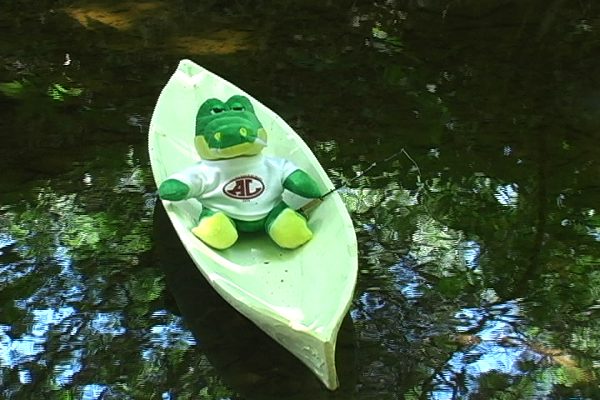
AL fishing
Entries are being accepted now through September 2017. The winner will be announced at the Big Trucks event on September 23, 2017. If you need further information or need an AL to take with you on vacation please call the Avon Lake Engineering Department at 440-930-4101.

